Devices Profile Feedback Workshop

August 24, 2004

Intel Corporation, Lexmark International Inc., Microsoft Corporation and Ricoh Corporation, co-developers of the Devices Profile for Web Services specification, are hosting a 1-day Feedback Workshop on Tuesday 24 August 2004 from 9am to 5pm with breakfast available from 8am.

The 1-day Feedback Workshop is an open forum for spec authors to share background information on the design of the specification and to receive feedback, and for software vendors and other interested parties to discuss their ideas about the practicality of implementing the Web Services specification.

Note that in order to attend this event, the attached feedback agreement MUST be reviewed and signed by each attendee - either before or at the Workshop event.

This Workshop will be held at Lexmark's campus in Lexington, KY - see below for location details. For more up-to-date information on the location, please visit the following site:

http://msdn.microsoft.com/webservices/community/workshops/

Wireless Internet connectivity will be available for this Workshop. Breakfast, lunch, and afternoon snacks will be served, but participants will be responsible for their own dinner arrangements.

As with previous Workshops, these events are open to anyone who desires to participate.

Feel free to pass this invitation along, either in your company or elsewhere. This is an open forum. No invitation is required, but the event hosts do appreciate an RSVP to facilitate accurate logistics planning. The list of attendees and general Workshop results will be made public after the Workshops.

Thank you and we look forward to your participation.
Intel, Lexmark, Microsoft and Ricoh

Workshop Location Details

The Devices Profile for Web Services Feedback Workshop will be held at Lexmark International in Lexington, KY on August 24, 2004 in building 082, shown below:

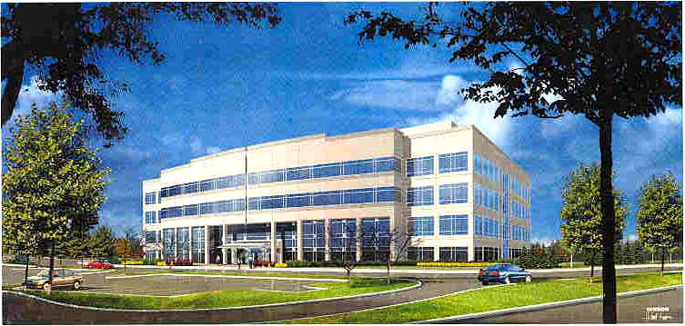

Address:

Building 082,
Lexmark International Inc,
740 New Circle Road,
Lexington,. KY 40550
Closest Airport:
Lexington (LEX)

Map and Directions:
See below

Contact Information:

Suzanne Monks, Administrative Assistant
859-825-4333
smonks@lexmark.com

Don Wright, Director, Alliances and Standards
859-825-4808
don@lexmark.com

Lexmark is located at 740 New Circle Road, Lexington. Ky. Building 082 is located on the main campus and can be reached by entering off New Circle Road and following the yellow highlighted roads as shown below.

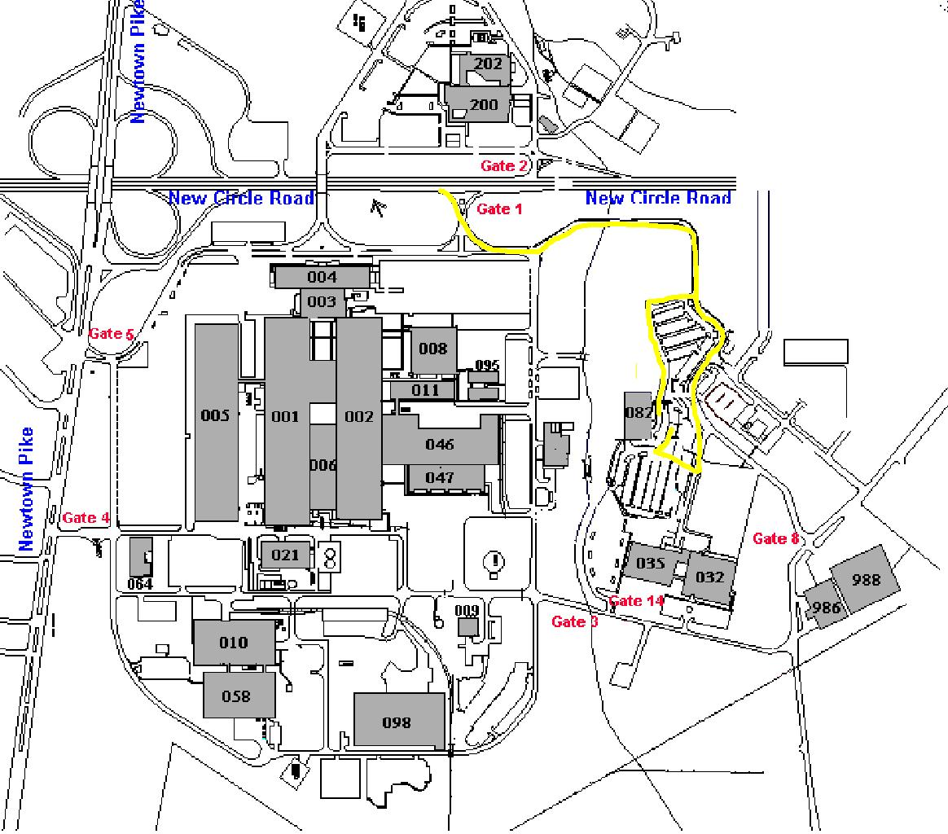

Lexington (LEX) can be reached easily by most major airlines. In addition the Louisville KY (SDF) and Cincinnati OH (CVG) (actually located in Kentucky) airports are approximately 80 miles away from Lexington. Cincinnati is a major hub for Delta Airlines. In addition to all major airlines, Louisville is also serviced by Southwest Airlines.

From the Lexington Airport, the vicinity of Lexmark can be reached as shown below:

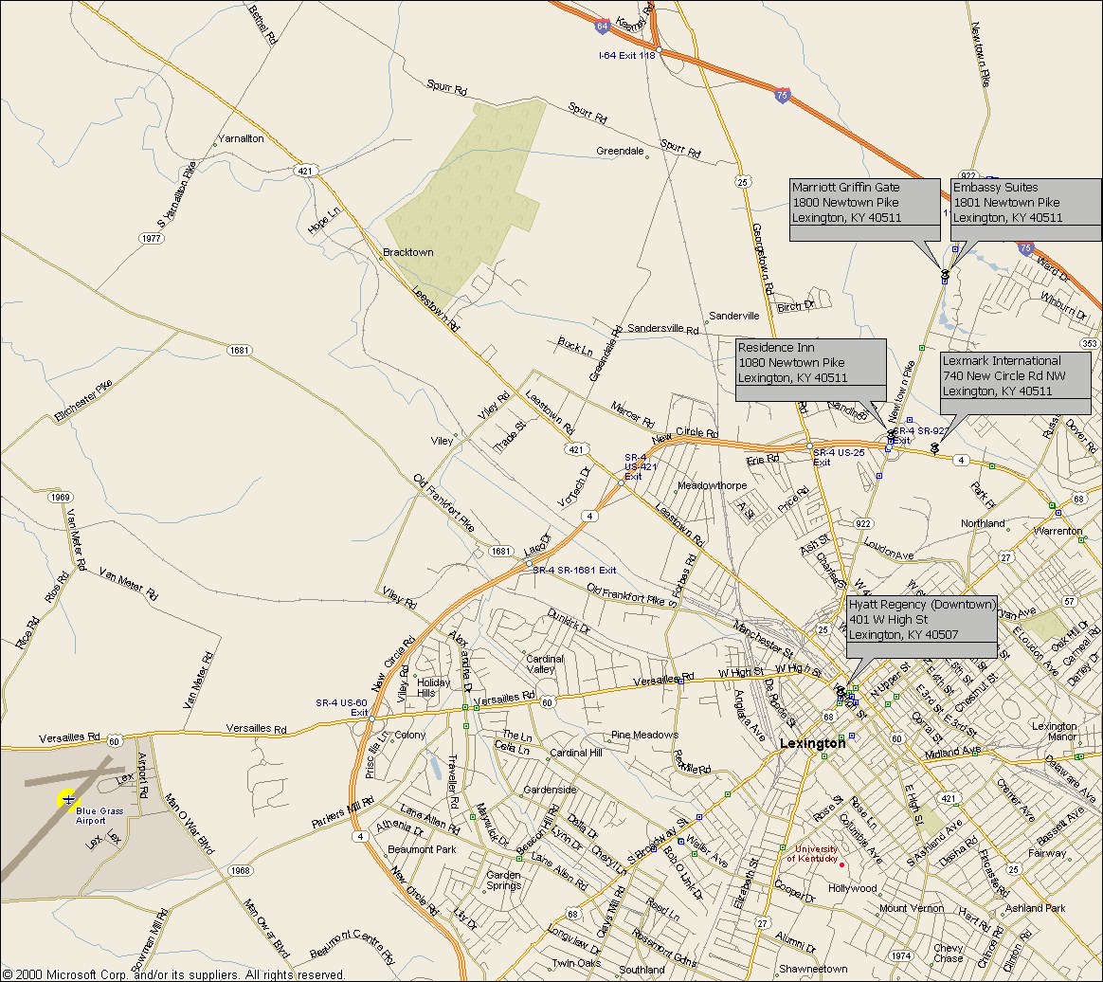

From the Cincinnati Airport, follow the route below to get to Lexington:

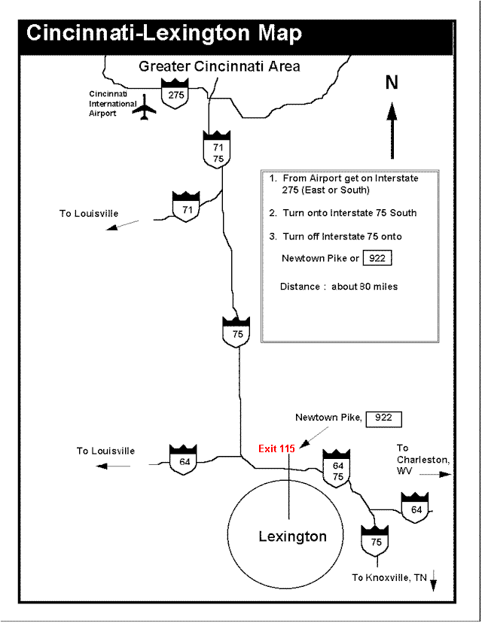
The following hotels have negotiated rates for Lexmark customer, partners and other participants in Lexmark events:

Lexmark Hotels in Lexington, Kentucky

Hotel | Lexmark Rate | Regular Rate | General Information
Embassy Suites  1801 Newtown Pike  Lexington, KY 40511  859-455-5000 | $94 | $159 | All suite hotel. Full service. Typical suite is 380 square feet.  Complimentary: Full, hot breakfast. On-site health/fitness center.
Radisson Plaza Hotel  369 West Vine Street  Lexington, KY 40509  859-231-9000 | $72 | $134 | Very nice hotel. Full service. Located Downtown near shops and restaurants. Full service. Excellent value for the money.  Complimentary: Parking. Shuttle to/from office and to/from airport.
Marriott’s Griffin Gate  1800 Newtown Pike  Lexington, KY 40511  859-231-5100 | $83 | $155 | Full service hotel. Note: Rate may not be available for all stays.  Complimentary: Transportation to/from airport. On-site health/fitness center.
Residence Inn  1080 Newtown Pike  Lexington, KY 40511  859-231-6191 | $83 to $68 depending on length of stay | $149  depending  on stay | Limited service, extended stay hotel. All suites. Kitchen in each unit.  Complimentary: Buffet breakfast..
Sheraton Four Points  (formerly Wyndham Garden)  1938 Stanton Way  Lexington, KY 40511  859-259-1311 | $61 | $119 | Full service hotel.  Complimentary: Breakfast buffet with coupon at check-in. Transportation to/from airport and to/from Lexmark.

Several of these hotels are located nearby as shown on the map below:

