MFD Face-to-face Meeting February 7-8, 2008
Attendees:
Attendee | Company | Email Address
Ron Bergman | Ricoh Co. | ron.bergman@ricoh-usa.com
Shah Bhatti | Samsung | shah.bhatti@samsung.com
Nancy Chen | Oki Data | nchen@okidata.com
Peter Cybuck | Sharp | cybuckp@sharpsec.com
Lee Farrell | Canon Inc. | lee.farrell@cda.canon.com
Nam Heo | Samsung | n.heo@samsung.com
Rick Landau | Dell | Richard_landau@dell.com
Harry Lewis | InfoPrint Solutions | HarryL@us.ibm.com
Ira McDonald   | High North | blueroofmusic@gmail.com
Joe Murdock | Sharp | jmurdock@sharplabs.com
Glen Petrie | Epson | Glen.petrie@eitc.epson.com
Ole Skov | MPI-Tech | ole.skov@mpitech.com
Jerry Thrasher | Lexmark International Inc. | thrasher@lexmark.com
Bill Wagner (phone) | TIC | wamwagner@comcast.net
Dave Whitehead | Lexmark International Inc. | david@lexmark.com
Craig Whittle | Sharp | cwhittle@sharplabs.com
Don Wright | Lexmark International Inc. | don@lexmark.com
Pete Zehler | Xerox | peter.zehler@xerox.com

Coordinate discussion
- Goal: need common terms for coordinates for clipping, magnification, and other transformations
- The coordinate systems will be taken from existing standards or products in market
- All diagrams assume
  - The content faces the reader
  - The relative movement of the media with respect to the hardware is towards the top of the page
    - For example the Print Device assumes the media is fed through the marker starting at the top edge. It makes no difference if the media moves through the marker or the marker moves past the media.

- Print device coordinate system
  - Feed and cross-feed directions are used
    - 0,0 upper left corner of the leading edge
    - Positive down

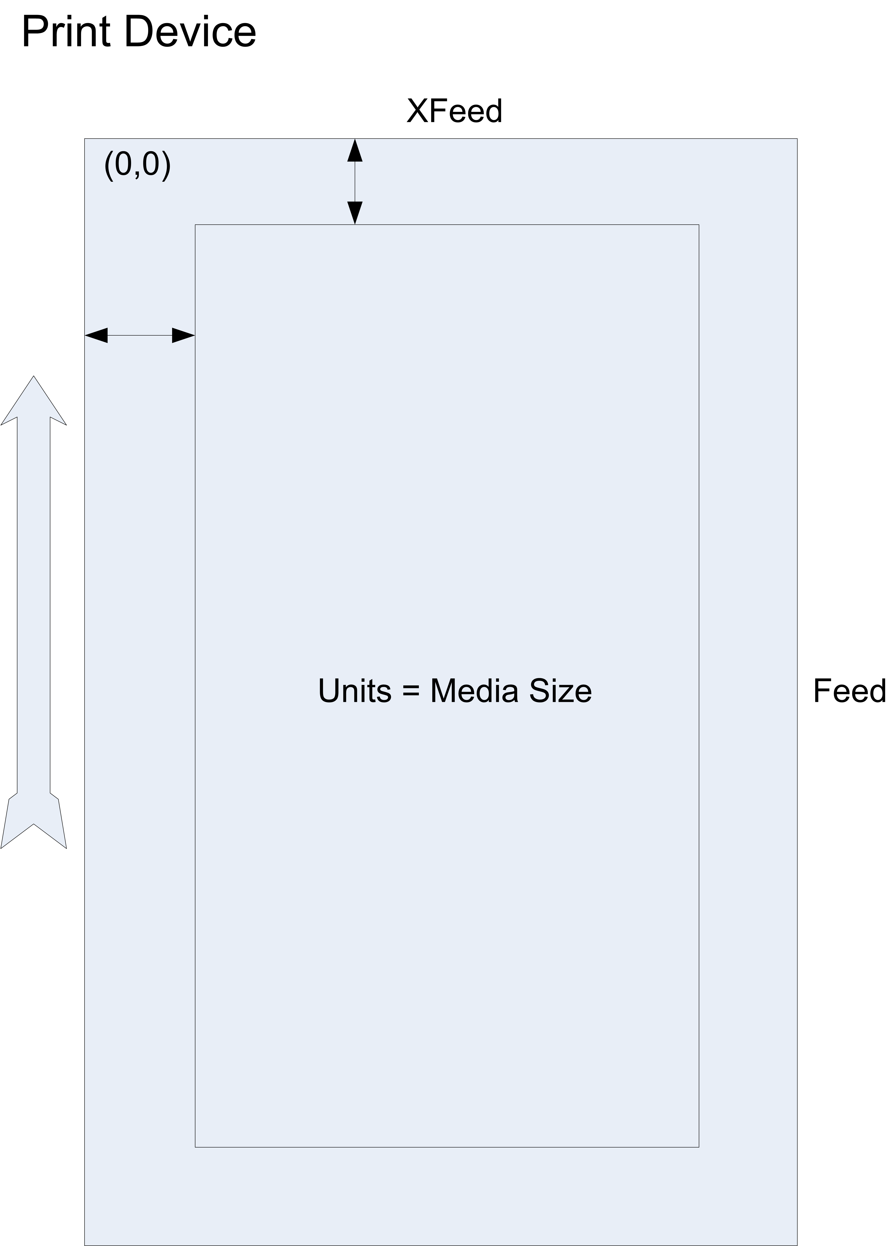

- Print service
  - Same logical coordinate as print device assumed based on IPP
    - The specified edge is always with respect to the document as if the document were a portrait document. If the document is actually a landscape document, the client supplies the appropriate transformed value. For example, to position a staple in the upper left hand corner of a landscape document when held for reading, the client supplies the 'staple-bottom-left' value (since landscape is defined as a +90 degree rotation from portrait, i.e., anti-clockwise
    - Print Service responsible for actual translation to Device coordinates
  - The Production Printing specification explicitly covers the coordinate system. For the purposes of this discussion the Production Printing coordinates will be ignored
    - The origin (0,0) is the bottom-left corner
    - The x-axis is defined to be along the bottom edge, with positive values extending in the direction of the right edge. The y-axis is defined to be along the left edge, with positive values extending toward the top edge.
  - X must be <= Y
  - X offset and Y offset and X, Y position are defined
  - X and Y units in MediaCol are not defined
  - Logical coordinates ignore the actual feed direction which is determined by media tray
  - Note: input tray has information about feed direction (it should be in the semantic model).

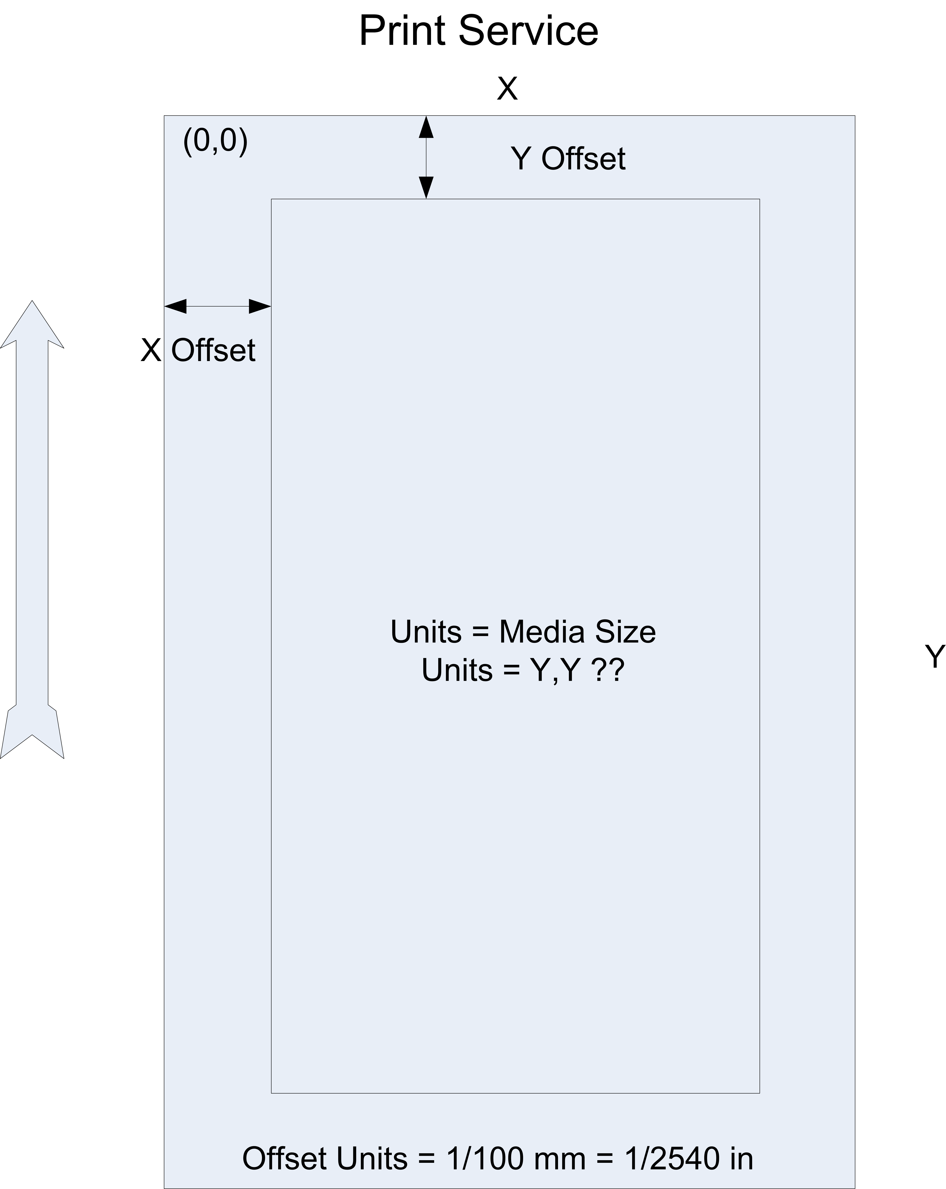

- Scan device
  - Origin and feed direction same as print device
  - Sides: North, South, East, West (per typically location of compass locations)

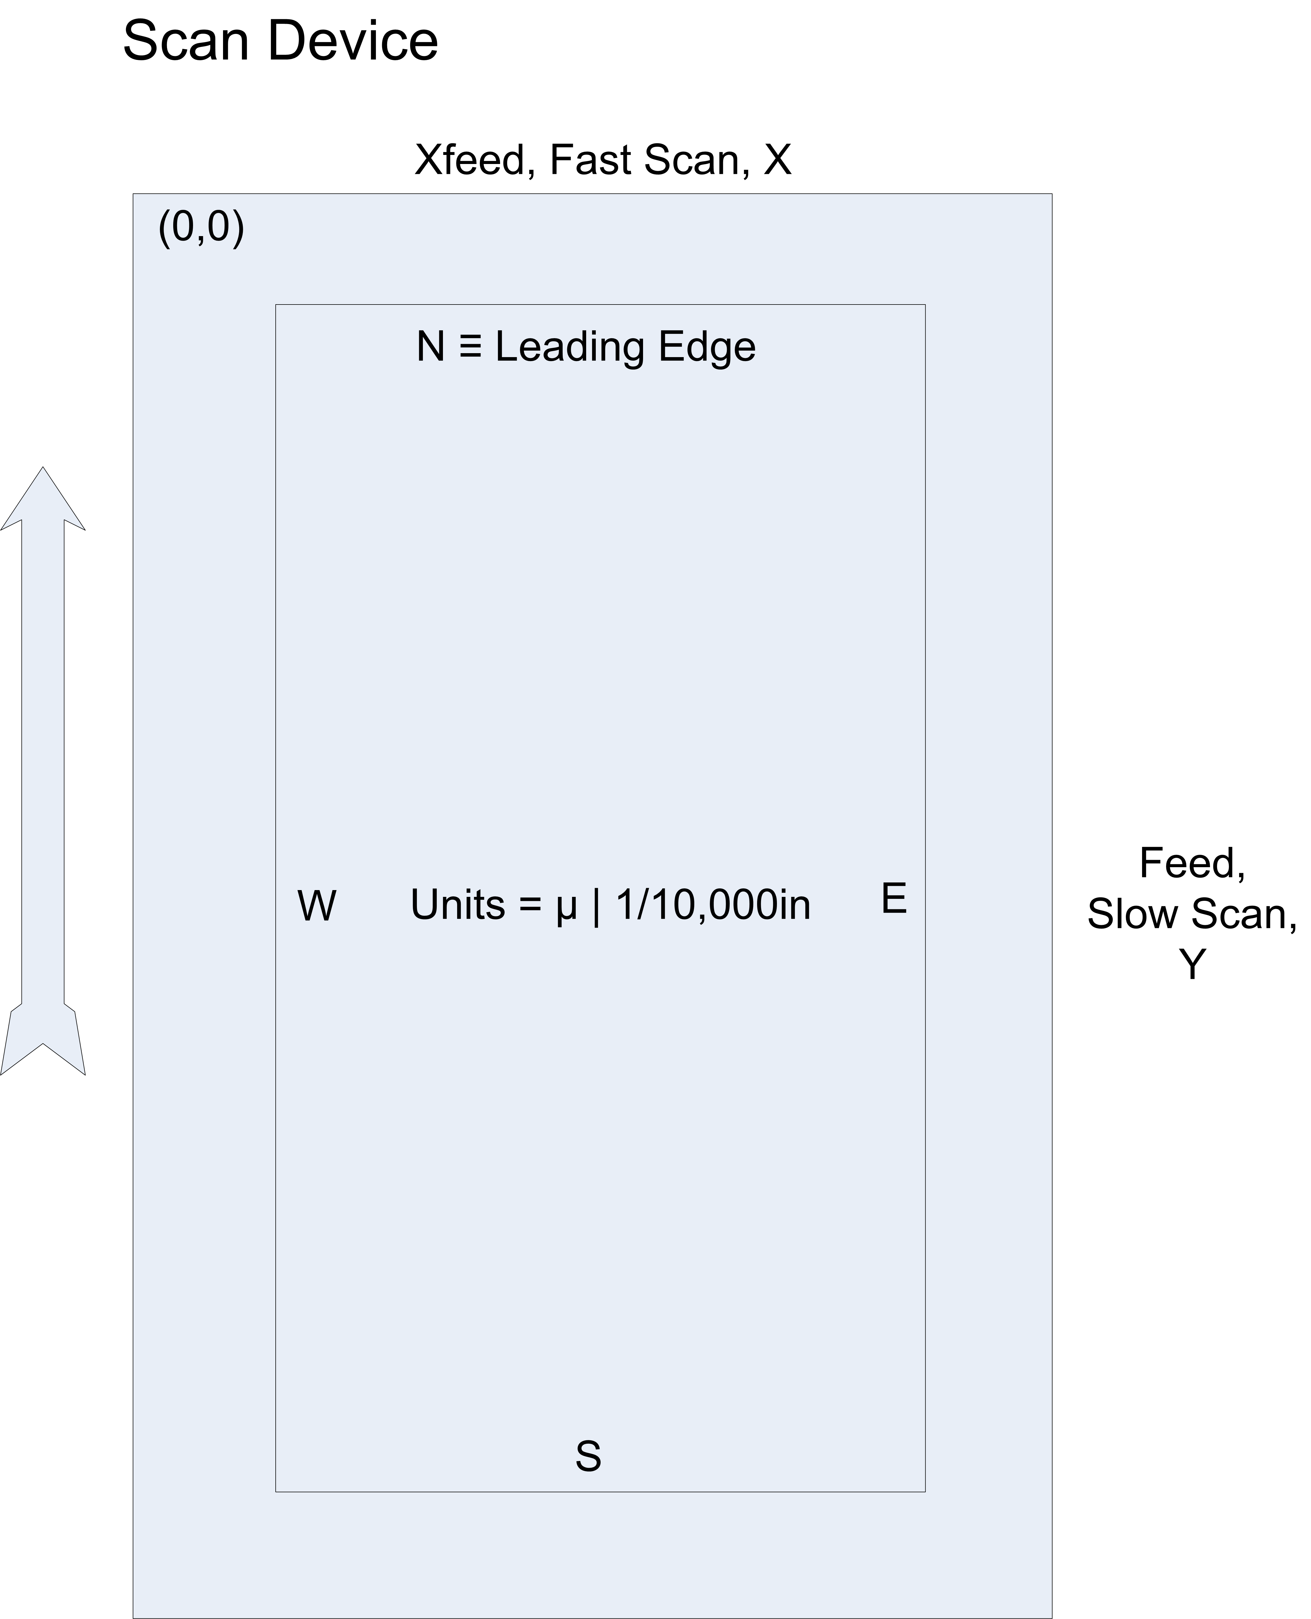

- Scan service
  - Same coordinates as print service
  - Scan Regions have x-offset and y-offset
    - Although not shown there can be multiple Scan Regions per media sheet side
    - Each Scan Region maps to an image
  - Height and width are also specified (“scan-able area”)

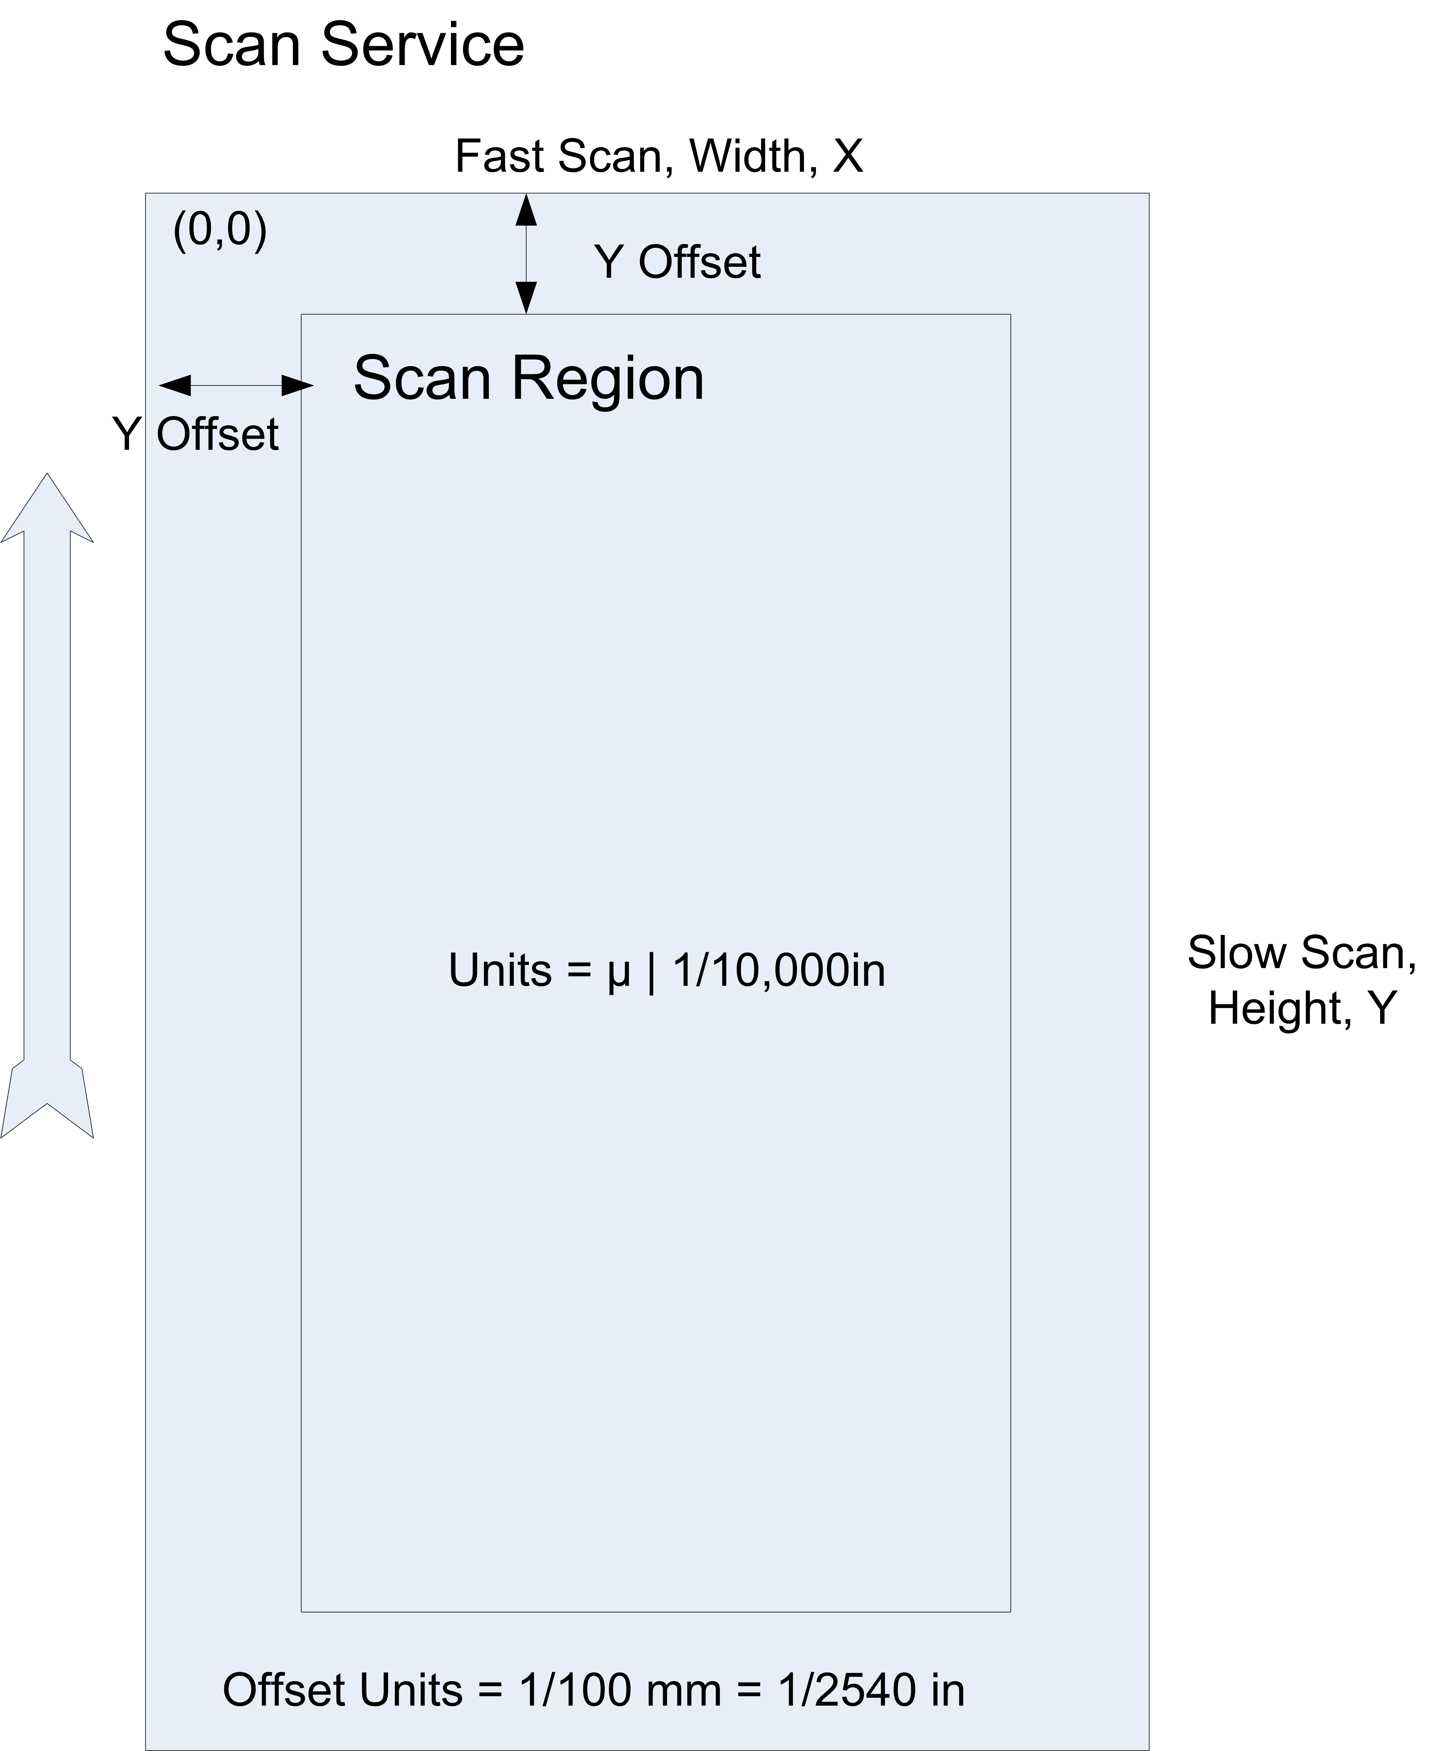

- Document format (output of scan service)
  - Same logical coordinates as print device
    - transformation to other coordinate systems (e.g. pdf with 0,0 at lower left) are handled by implementation
    - Origin relative to scan region
  - Media box: height and width
    - Media Box may be unknown or not applicable (e.g. jpeg document format)
  - Image box (internal area for image)
    - The name used at the meeting was Content or Bounding box
    - This is where a scanned image is placed
    - There is only one image box for each media box
  - Semantic of the scan service’s Document Processing instructions that affect image layout (e.g. Rotation, Resize) will be describe in terms of the interaction of the Image and Media boxes
- Multiple images (N-down / N-up) combined before placed in the Image Box
- Document formats may require unique parameters to fit an image into a media box.
- There are Document Processing elements that affect layout: Rotation (orientation), resize/magnification/scaling, crop, offset/position/translation, and zoom. These are the basic transforms that need to be supported.
- User needs to be able to specify policy if image does not fit, and then preference for fit or clip needs to be specified.
- Image = Scan Region = Image Box
- Question: what happens when the content box is transformed?
  - Rotation always happen on center of content box
  - X,y can be negative
  - New content origin established northwest corner is new content origin
  - Fit = keeps aspect ration until the largest edge fits on media
- User experience (changing defaults), internal behavior / protocols much more detailed
- Resize (magnification, scaling)
  - Same aspect ration stated as a percentage
  - Offset same as rotation
- Cropping is not needed. It was already done when the scan region was specified
- Zoom is not needed now.
- Offset (position, translation) is +/- x,y of content box within media box

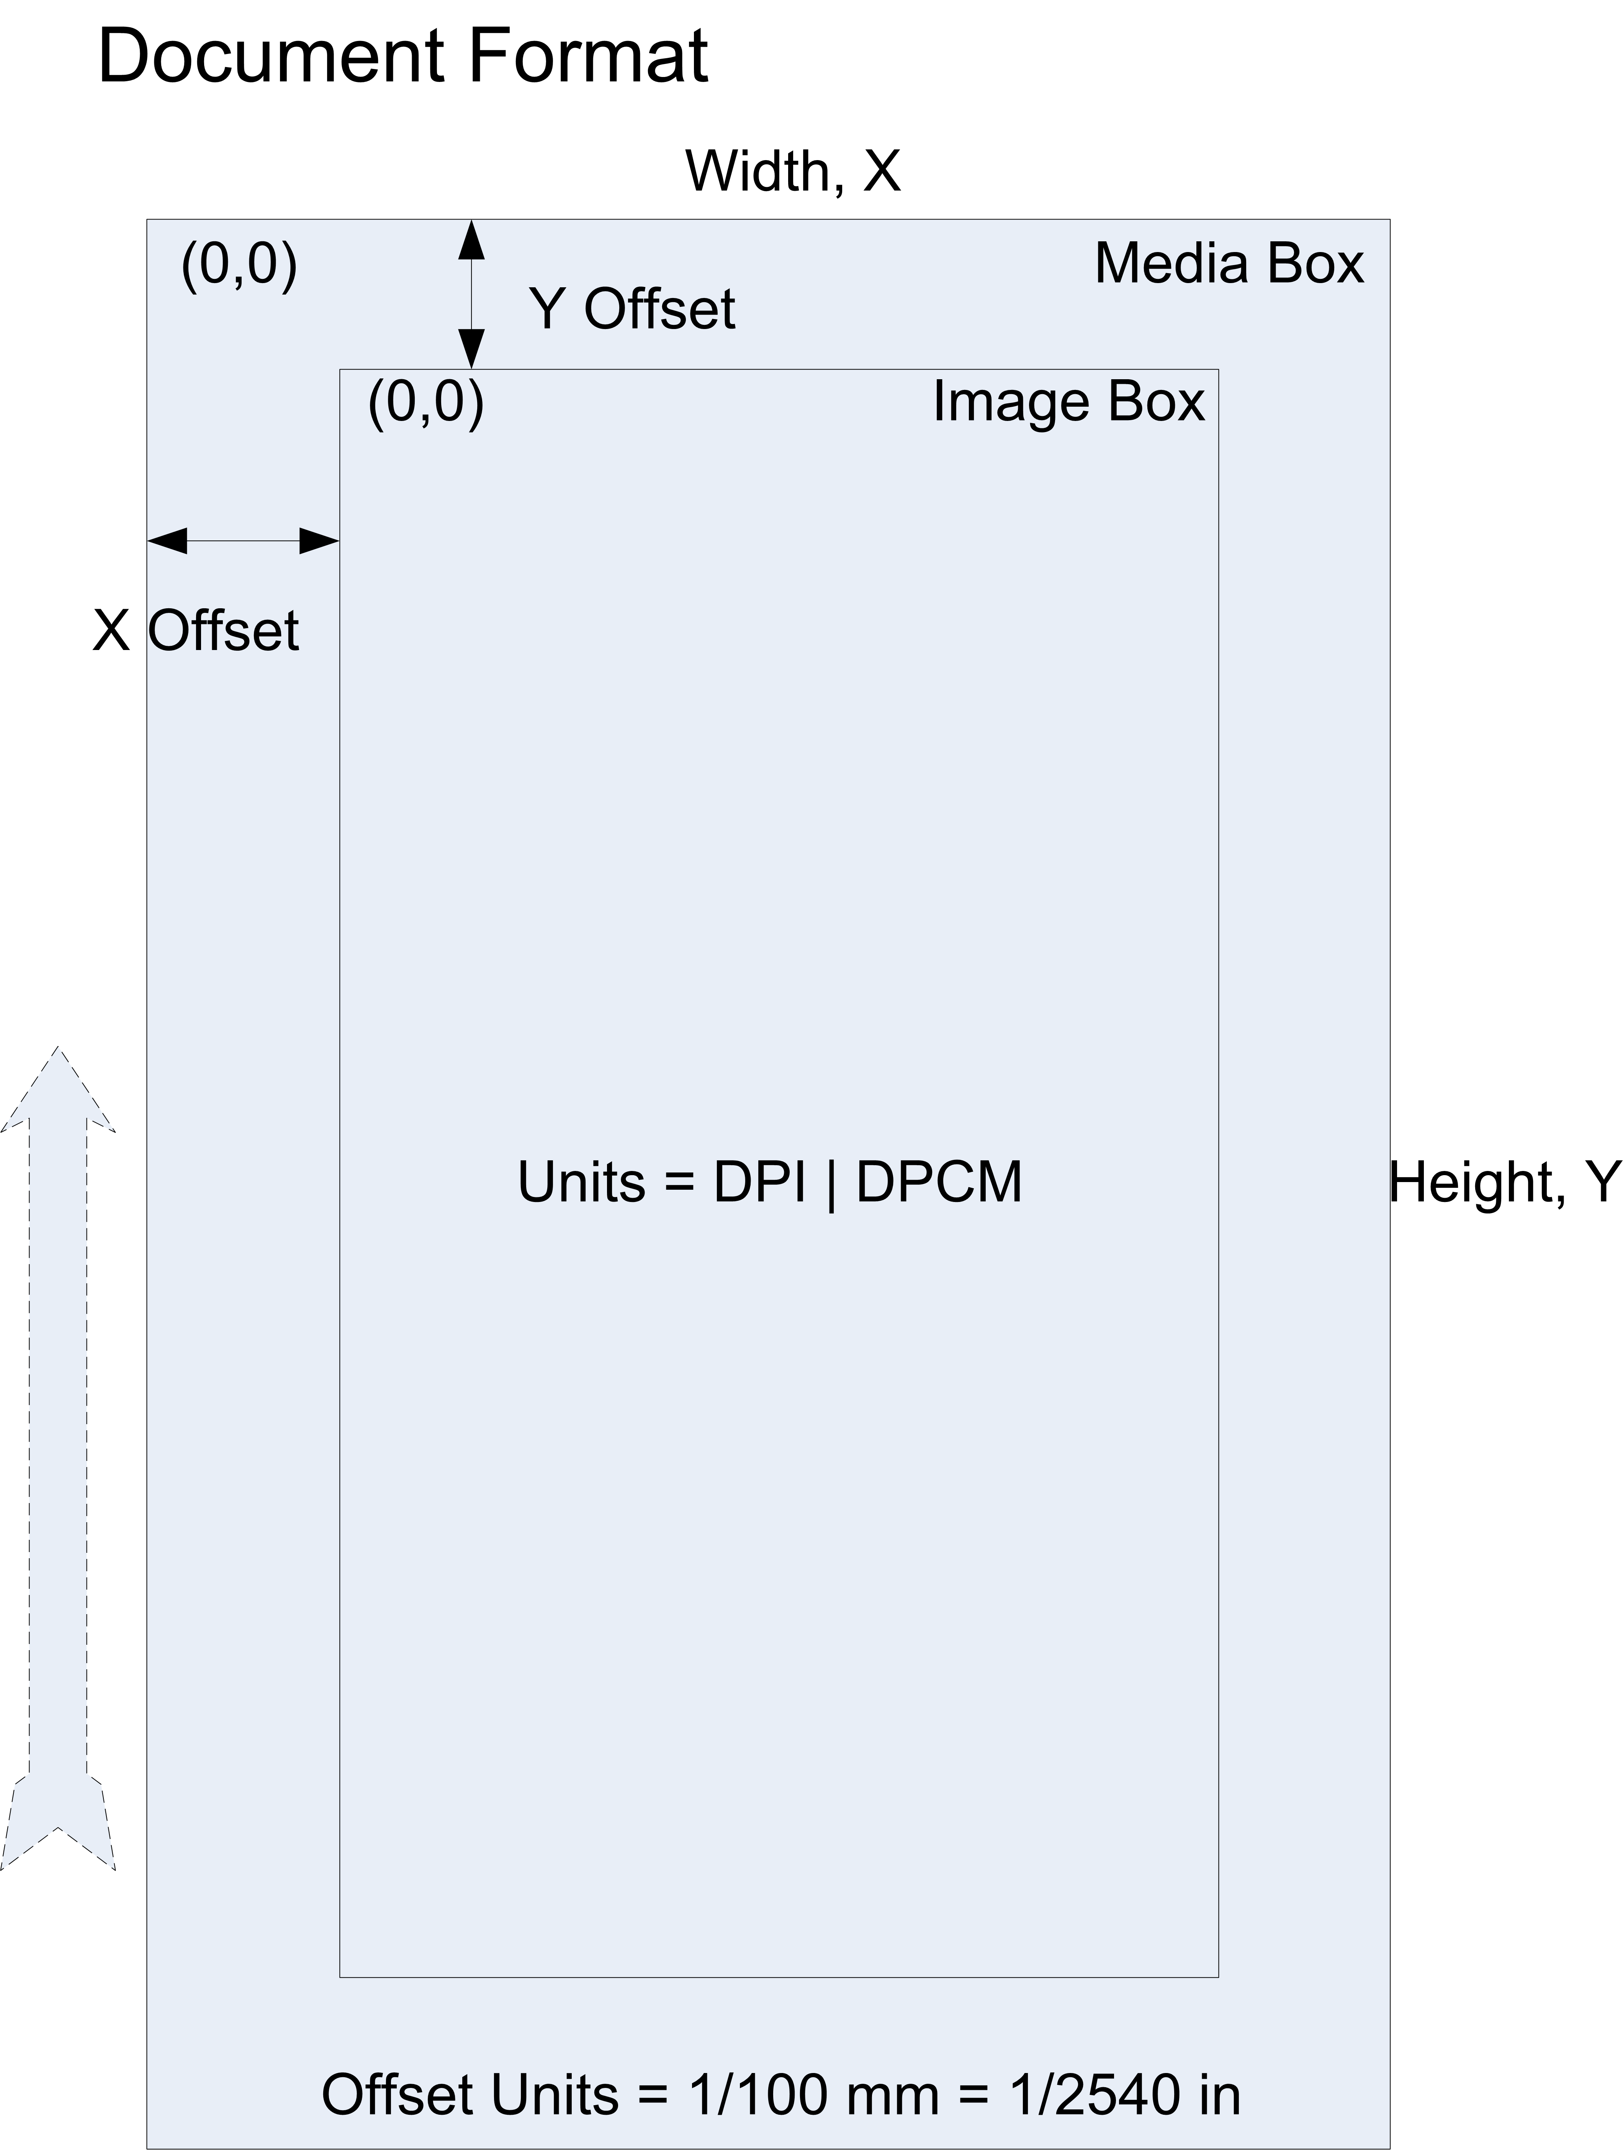

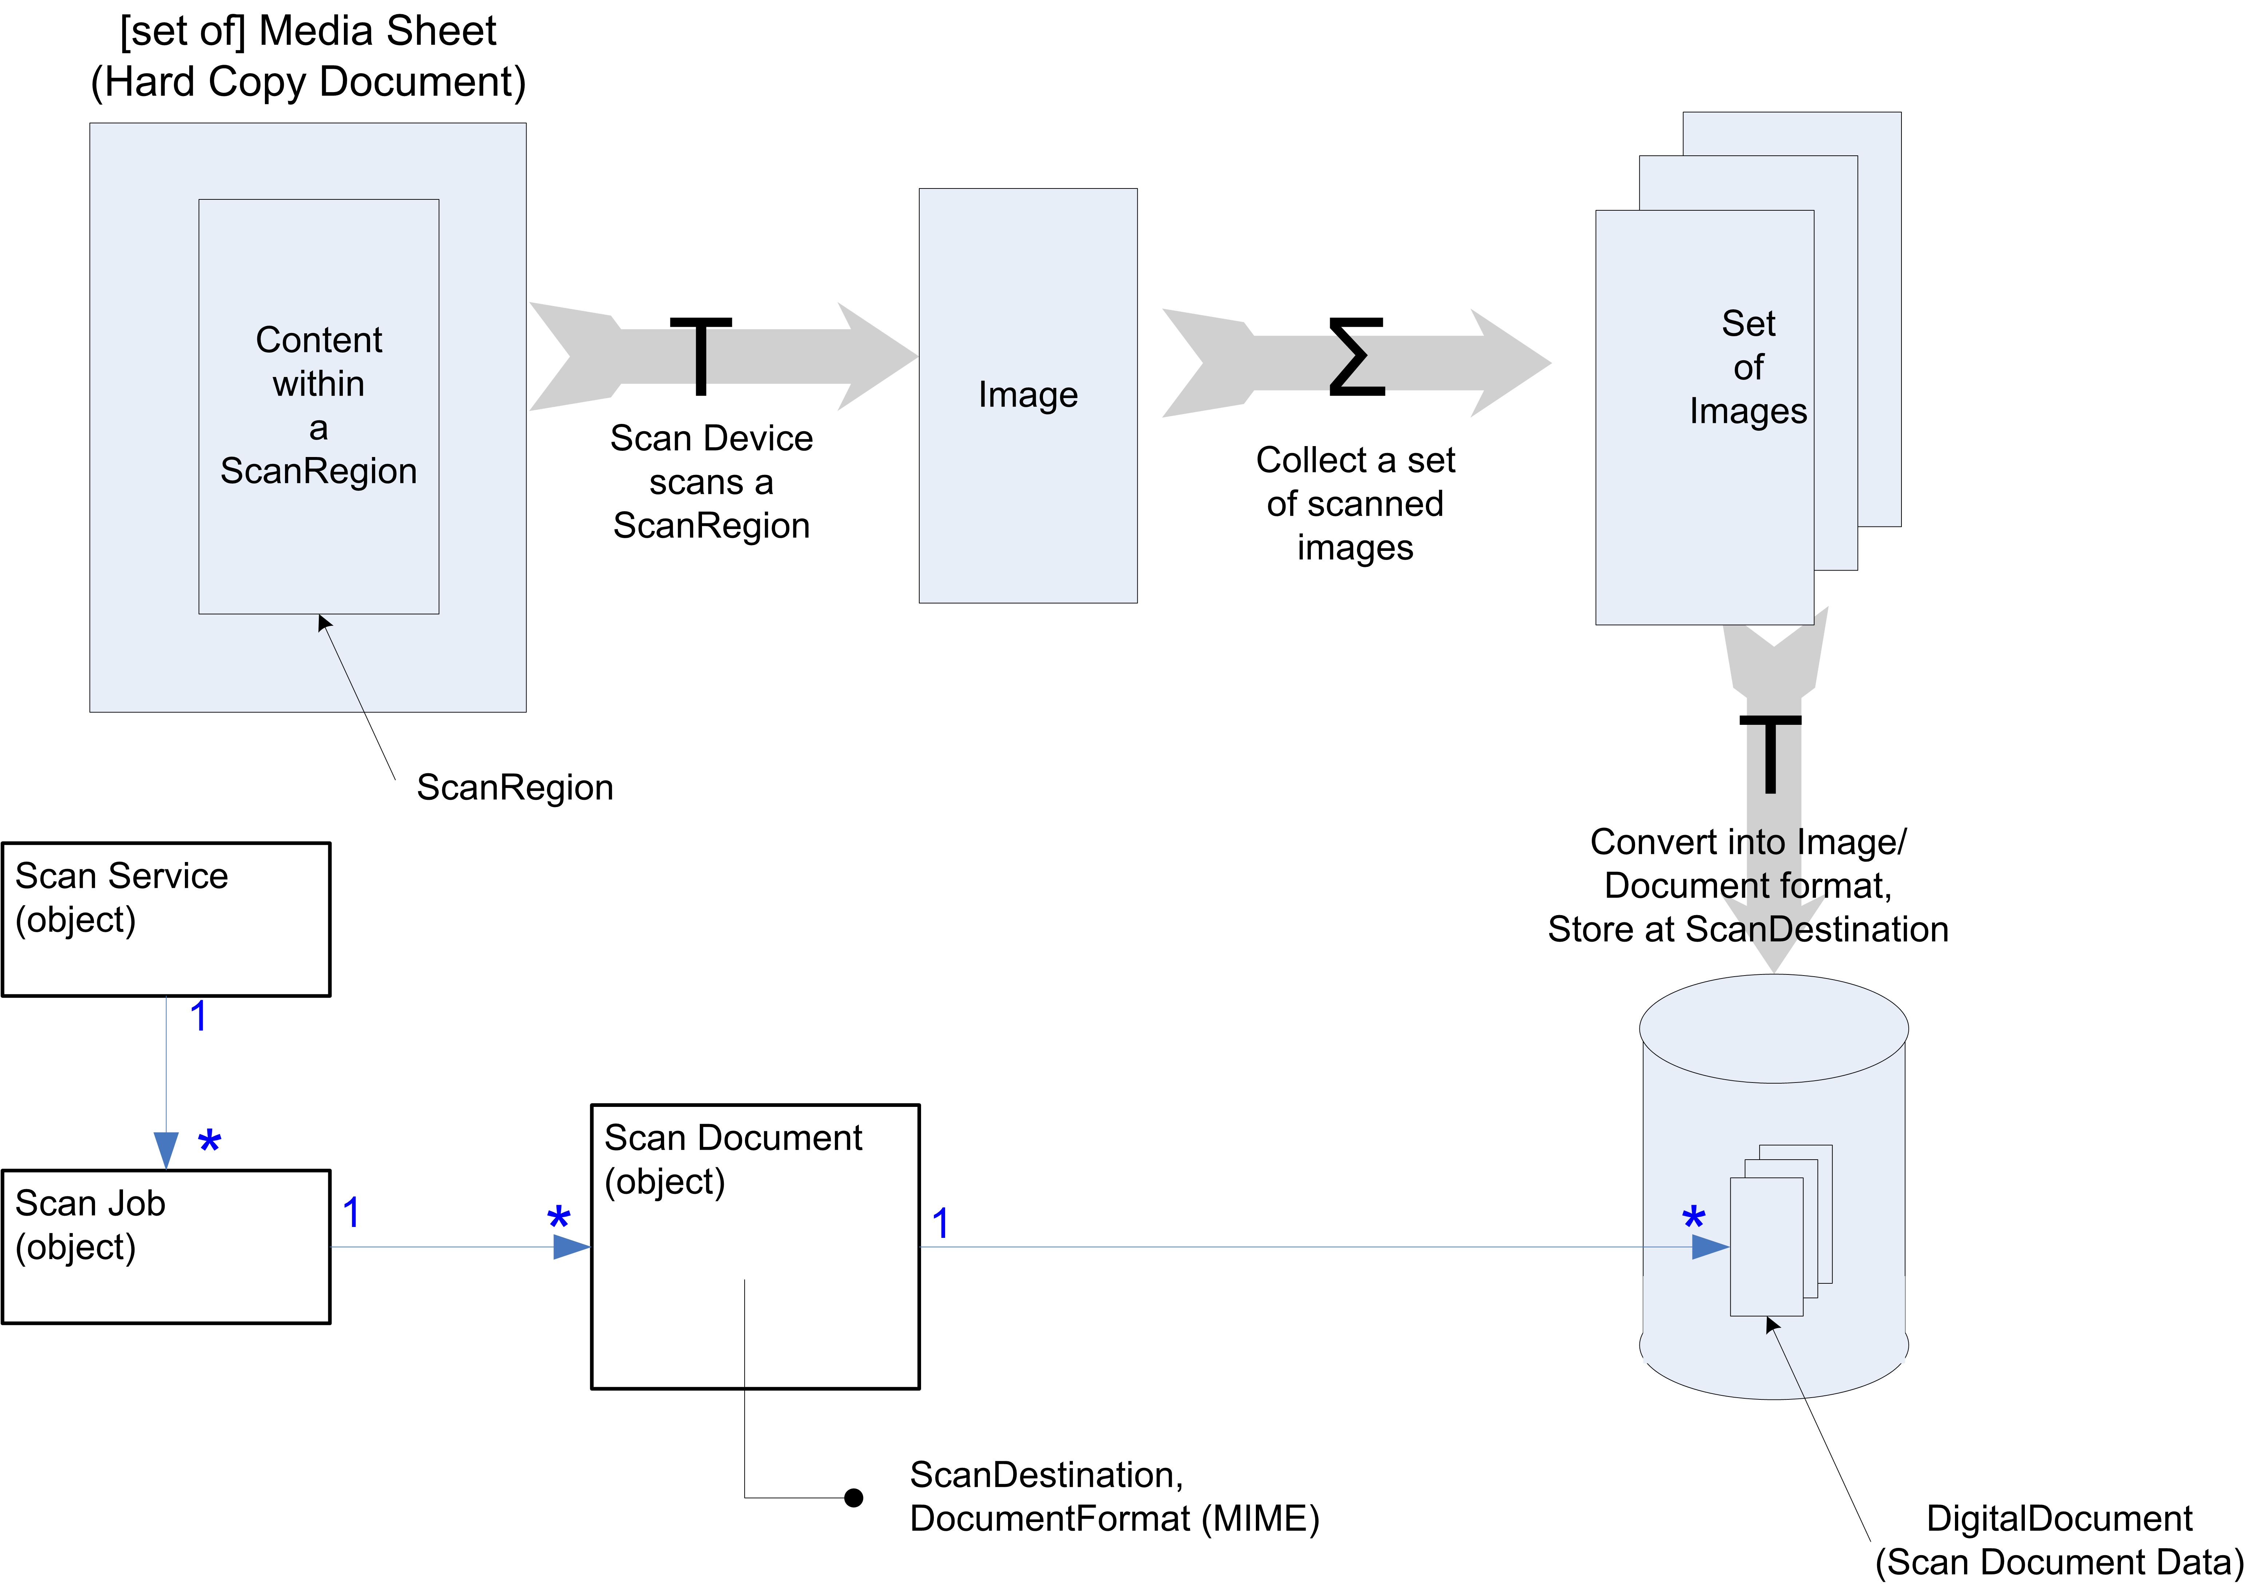

- We put down an impression onto Media and pull up an image from Media
  - Printing an image results in an impression
  - Scanning an impression results in an image
- Scan region: rectangle area to be scanned from which one and only one image is created.
- Hard copy document has one or more medias sheets with one or more scan regions that one contain image (result of a transform)
- Scan Document (Document object): information about document within jobs, contains document attributes including Document Format and Scan Destination. The Scan Destination contains the document URL(s)
- Digital Document (alias Scan Document Data): The output of the Scan Service. The images acquired from the Scan Regions of the Hard Copy Documents are encoded into a file format (i.e. DocumentFormat) and stored at a specified location (i.e. Scan Destination)
  - Scan Document can have multiple Digital Documents
  - The Scan Service declares the DocumentFormats it supports through the Service’s Capabilities
- Scan Service contains one or more Scan Jobs which contains one or more Scan Documents which reference one or more Digital Documents.
  - The Scan Document specifies the documents format (MIME type) of the Digital Document

Document review
GP12-OutputDocumetSize – delete this (still need media box)
GP13-resolved
GP14-light source – resolved
GP15-document type-resolved (see list: auto, photo, negative, text, photo, magazine, haftone, mix)
GP16- autos skew correction
What about line removal, de-speckle, exposure, and other image processing?
Harry to provide list from TWAIN
GP17-Document page element detect (auto segmentation)
Either the regions are manually specified or “document page element” is selected. This attribute should be multivalued/type III
GP18- Content Recognition (include OCR, ICR, barcodes, forms-elements)
PZ1-ScanServiceConfiguration different view (“configuration” = subunits used within scan service) of data also in subunits.
Scanner device to be describe later
PZ2-coordinate system resolved
GP20-image processing functions (including exposure) – started
What about grayscale, color, monochrome, color conversion. Need to add color attributes.

